Welcome to my drawing class!
In this class, I will teach you how to design an animated character.
Now, starting with the eyes is recommended so we can get a good idea of where to place the head, like so…
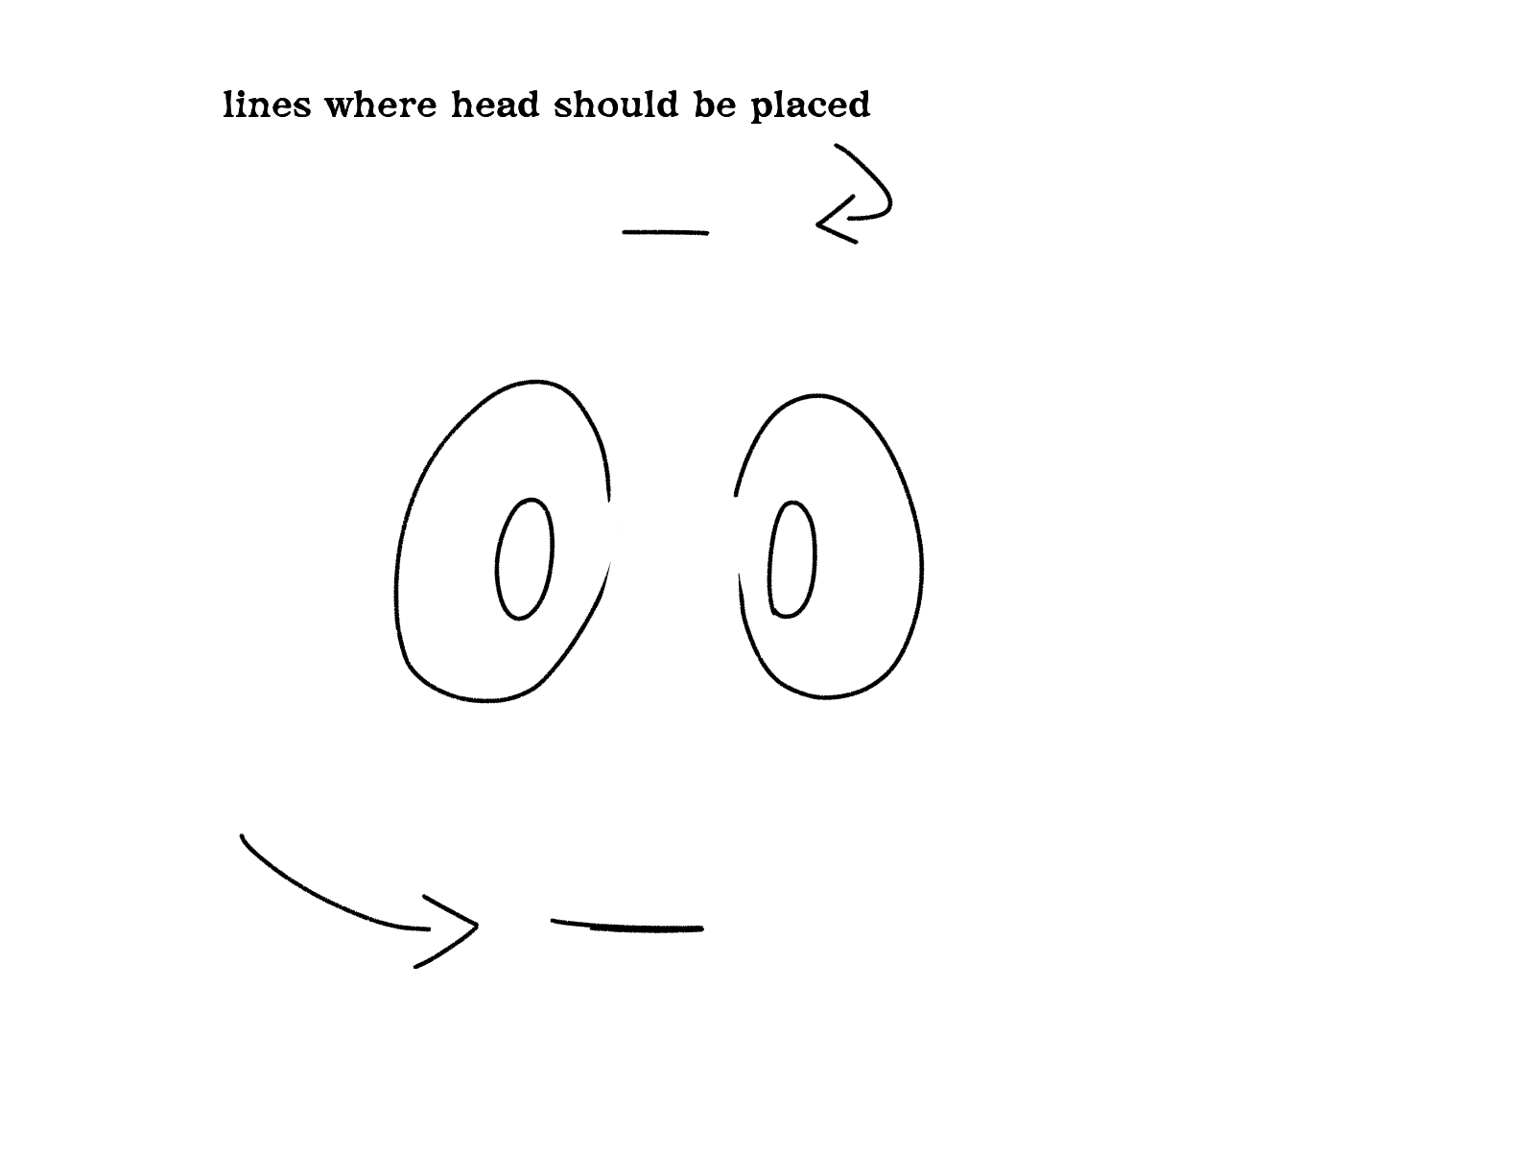
I’m drawing the eyes like this, but you can draw the eyes however you want, as long as they’re aligned.
If you want to go for more of a cartoon look, try to draw the eyes the way I did.
I drew examples of a variety of eyes below.
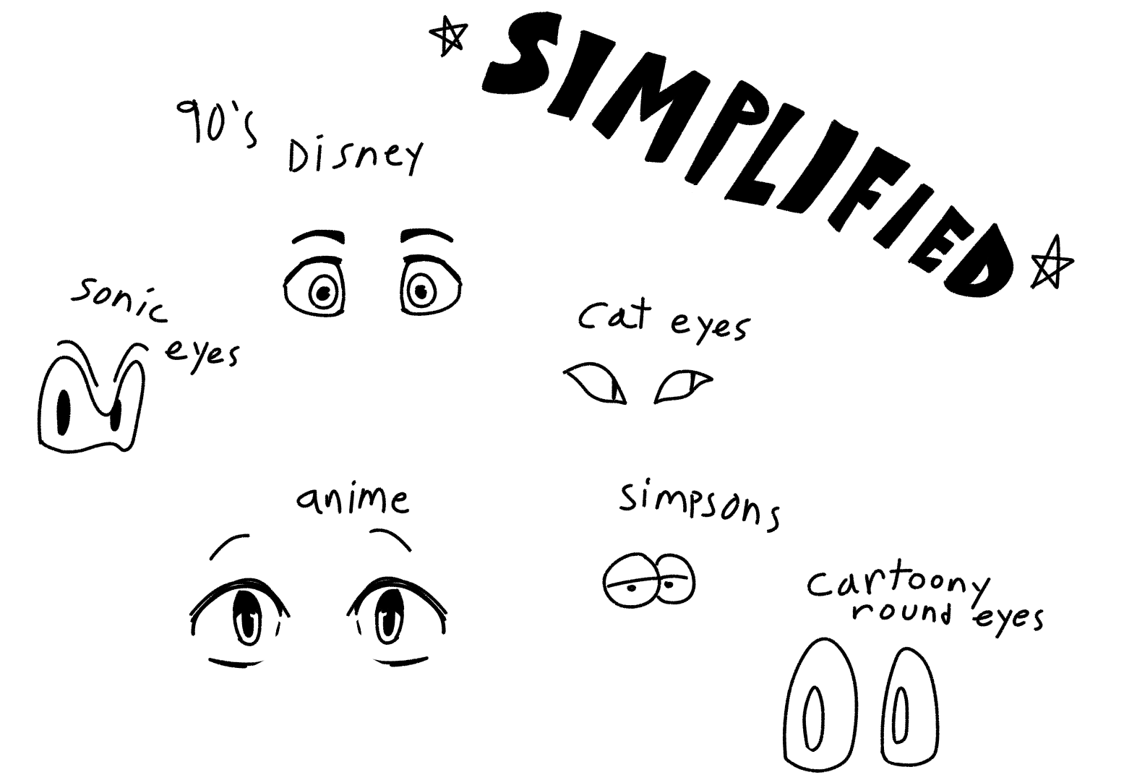
You can choose to reference any of these for your character.
Drawing straight lines directly underneath as well as above your eyes is a good way to see if they’re aligned.
If you have trouble drawing straight lines (I do too!), then you should use a ruler and draw the lines directly beneath it.
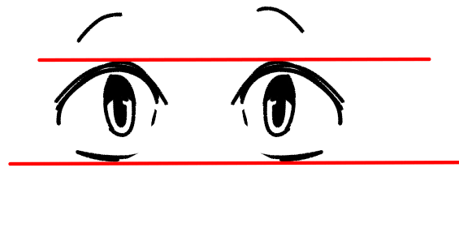
You can check this, fix your character’s eyes and erase the straight lines afterwards.
Now that we’re done with the eyes, let’s move onto the head.
The head is where things get interesting.
There are many different ways to draw the head, and it all depends on where you position the eyes and who the person is. See below for examples.
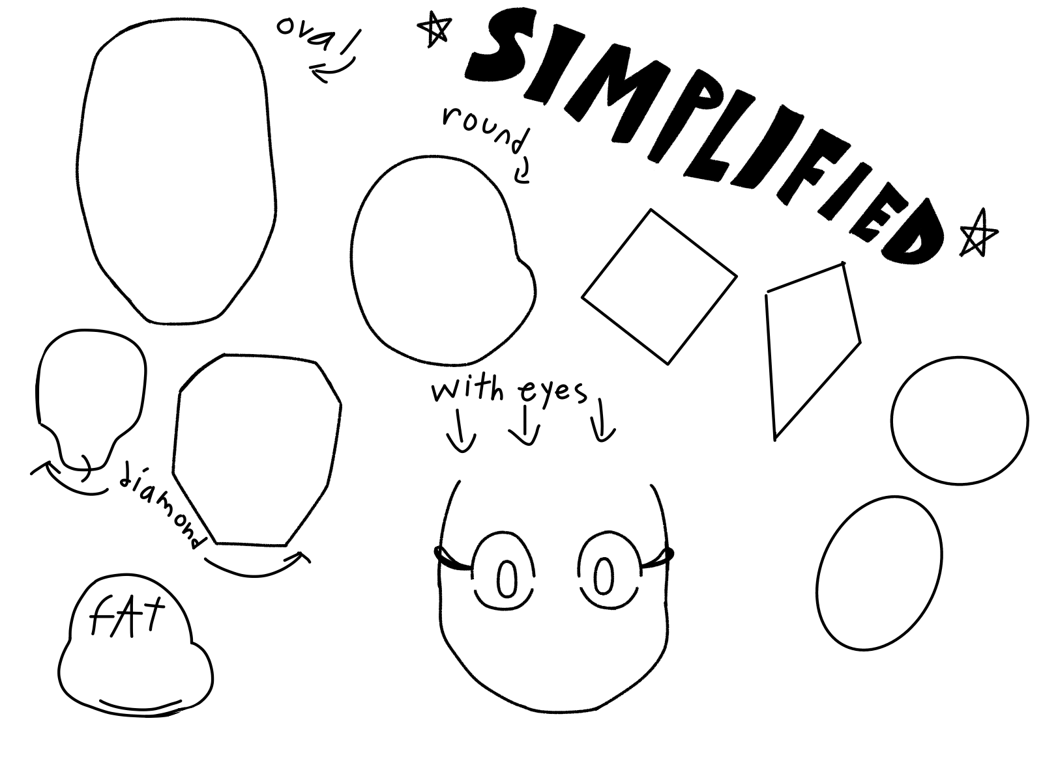
People have different face shapes as well as different body weights. When you make your character, you have to think of this.
Next, let’s move onto the nose. There are many different types of noses you could do, for example…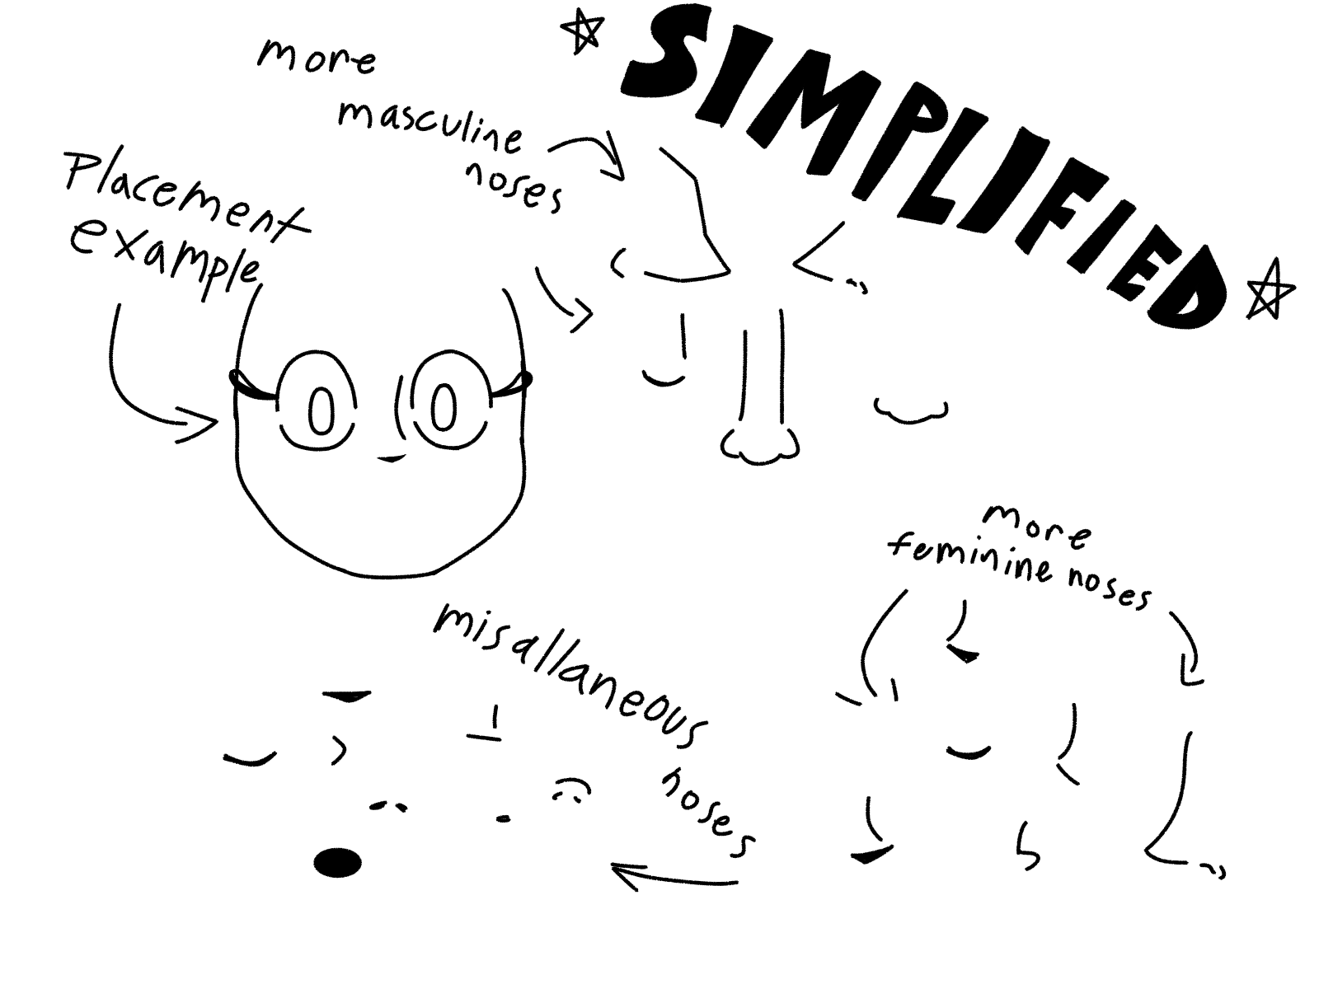
Or you could just skip the nose completely! Feel free to make it look cartoony as you like.
People usually like noses though, and it is recommended.
Also, you should add some pizazz to the face, like blush marks or small zigzaggy lines.

